

Proposal
Installation of Garmin G1000 Integrated Flight System
With Synthetic Vision and ADSB IN & OUT

Mountain King Air LTD.
King Air B200, N74AW, BB-1233

MAYOAVIATION.COM
January 19, 2018
Mr. Butch Weaver |  | Aircraft Make: | Beechcraft
Mountain King Air LTD |  | Aircraft Model: | B200
P O Box 17088 |  | Aircraft Serial: | BB-1233
Boulder, Colorado 80308 |  | Registration No.: | N74AW
303-941-5150 |  | Quote No.: | 2018-01-19

Dear Mr. Weaver,
Thank you for considering Mayo Aviation for your aircraft Avionics and Service needs. We are pleased to present you with this proposal for the work specified on your aircraft. A summary of the requested work is below. Detailed information follows.
Item Description | Quoted Price
Bendix/King AeroVue Integrated Flight Deck | $448,000.00
Bendix/Kings Cash Back Incentive to operator | $25,000.00

At Mayo Aviation, we strive to provide our customers with unequaled customer service and quality workmanship. All work performed by our technicians on your aircraft will meet or exceed the quality and safety standards established by the Federal Aviation Administration.
I appreciate that you are giving Mayo Aviation the opportunity to provide you with this proposal. I look forward to working with you soon. If you have any questions or concerns, please contact me at your convenience.

Warm Regards,
James Bohart
James Bohart
Avionics Manager
Mayo Aviation, Inc.
Mobile: 864-804-8411
Email: jamesb@mayoaviation.com

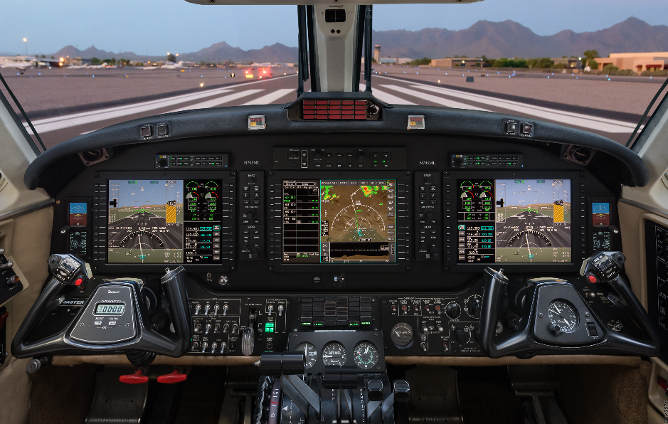
Bendix King AeroVue Integrated Flight Deck for the Beechcraft King Air B200
Bendix/King offers unprecedented Value for the Beechcraft King Air B200, this revolutionary Integrated Flight Deck incorporates all-new components for your aircraft, enjoy all the benefits of an integrated flight deck including new radios, GPS units, Transponders, Autopilot and more. Fly like it’s always VFR, with three 12” displays with standard SmartView Synthetic Vision system greatly enhancing situational awareness. Flexible user interface provides you with choices for how to use the system.
Puts you in control. The standard Cursor Control Device means ease-of-use when ﬂying through turbulence.
Ease of use. Enjoy a tighter instrument scan with engine indications and radio tuning located on the Primary Flight Displays. Flatter, drop-down menu options reduce pilot workload.
Professional technology. Shares proven technology and features found in Honeywell Epic avionics suites for leading business jets.
Latest, most advanced flight deck upgrade brings zero-time avionics, new glass displays, smooth flight control and HSI mapping to your Beechcraft King Air.
Equipped to meet and exceed airspace modernization initiatives for ADS-B and more.
Enables WAAS LPV approaches into thousands of airports — with Visual Approach capability for autopilot-coupled glidepaths to pilot-selectable minimums
Bendix/King AeroVue upgrade saves an estimated 250 lbs. over the avionics it typically replaces

Integrate Your Cockpit
Bendix/King AeroVue retrofit Suite integrates all primary flight, navigation, weather, terrain, traffic, radio frequency, engine and fuel data readouts on large-format, high-definition LCDs. The cockpit layout features three 12” Displays the MFD is flanked by Primary Flight Displays (PFDs) at the pilot and copilot positions with Interactive Navigation (INAV™) graphical flight planning

Look to the Future. In Virtual 3-D
For added visual orientation, Bendix/Kings SmartView™ Synthetic Vision Technology/ Chartview is included with your Bendix/King AeroVue Retrofit. Using sophisticated graphics modeling, the system recreates a 3-D “virtual reality” database landscape on the pilot and copilot PFDs. Thus, Garmin SVT enables you to clearly visualize nearby flight and enroute navigation features – even in solid IFR or nighttime VFR conditions.

Put it on Autopilot
The Bendix/King AeroVue system for your King Air also includes, a three-axis, fully digital, dual channel, fail passive Automatic Flight Control System (AFCS), that is capable of using all data available to the AeroVue, enabling it to maintain airspeed references and optimize performance over the entire airspeed envelope.

Fly with GPS, AHRS, RVSM and more
Other standard features of your King Air’s Bendix/King AeroVue Suite include WAAS-certified GPS navigation, dual integrated solid-state Attitude and Heading Reference Systems (AHRS).

WAAS Makes It Better
With dual VOR/Localizer/Glideslope receivers and dual TSO-c146a WAAS-GPS receivers, you have more options when it comes to flying and landing your King Air. Thanks to WAAS – the FAA’s Wide Area Augmentation System – thousands of previously fair-weather-only airports now have the potential to offer GPS-guided “Glide Path” approaches down to ILS-comparable minimums. And your Bendix/King AeroVue-equipped King Air comes ready to fly WAAS with full Class 3 Approach Capability.

Enjoy Seamless Mapping and Graphics
The King Air Bendix/King AeroVue MFD seamlessly integrates built-in terrain, obstacles and navigation databases, providing a clear, concise picture of where you are and where you’re heading. A Jeppesen® Database supports onscreen navigation, communication and mapping functions. Using information from the terrain and U.S. obstacles databases, AeroVue displays color coding to graphically alert you when proximity conflicts loom ahead. Your AeroVue also comes with Class-B TAWS (Terrain Awareness and Warning System) for an extra margin of safety in the air. Jeppesen built-in database of over 850 U.S. airport diagrams, helps monitor your location on unfamiliar airports. And preloaded Charts provide electronic versions of National Aeronautical (NACO) terminal procedures and approach plates for over 2,900 U.S. airports.

Get Weather, Radio and Traffic
Featuring an integrated Bendix/King Mode S Transponder, your King Air’s AeroVue will display Traffic Information Services (TIS) alerts to identify nearby traffic targets. In addition, the King Air AeroVue suite comes with Bendix/Kings DRD-2000 digital color radar. At 6.5 kilowatts, it packs the power to penetrate serious weather. Moreover, you’ll also have access to up-to-the-minute XM WX Satellite Weather™ services with the Heads-Up XM data link receiver. An XM subscription provides coverage for the entire U.S. – with NEXRAD images, METARs, TAFs, TFRs, lightning, winds and more. Plus, you can even select and enjoy over 170 audio channels of XM inflight entertainment (subscription required).

PROPOSAL DETAILS

- Provide and install a Bendix/King AeroVue Cockpit Retrofit Package per Bendix/Kings King Air B200 STC.
The installation will be comprised of:
    - Three (3) Bendix/King 12” Primary Flight Displays
    - Standard Synthetic Vision
    - Two (2) Bendix/King Audio Panels
    - One (1) Bendix/King RDR-2000 Weather Radar Transceiver
    - One (1) Bendix King Autopilot System
    - Two (2) Bendix/King WAAS GPS, COMM, NAV Transceivers
    - Two (2) Bendix/King Marker Beacon Systems
    - Two (2) Garmin RVSM Capable Air Data Transducers
    - Two (2) Garmin Mode S Transponders (ADSB)
    - One (1) Garmin GDL 69A XM Weather Receiver
    - One (1) Garmin TAWS Unlock
    - One (1) Garmin Flight Stream 510
    - One (1) Garmin Chartview Electronic Charts
    - One (1) Custom Cut and Painted Instrument Panel
    - One (1) Complete Overlay and Edge Lit Panel Refurbishment
    - One (1) Kit Miscellaneous Materials
    - One (1) Mid-Continent MD-302 Stand by Instrument
    - One (1) Blackhawk G1000-01/G1000-02 Engine Transducers
    - One (1) Used BF Goodrich PS-835D STBY Battery with rack
    - One (1) Used Collins ALT-50A Radio Altimeter

Labor and Material $378,500.00 Yes No

Note 1: A trade in credit of $25,000.00 for all removed equipment is included in this proposal, due to the large amount of used equipment currently on the market, this trade in credit may vary, all removed equipment is sold to avionics parts distributors all funds are applied to this credit.
Note 2: A Rockwell Collins ALT-50A Radio Altimeter and a BF Goodrich PS-835D Stand by battery are needed for this installation as they are not currently installed or do no interface with the G1000 package, and are included in the above pricing.

- Provide and install a Garmin G1000 Platinum Package per Garmin’s King Air 300 STC.

The installation will be comprised of:

    - One (1) Synthetic vision (SVT) for all three aircraft displays
    - One (1) Garmin Flight Stream 510
    - One (1) Garmin Chartview Electronic Charts

Labor and Material $19,000.00 Yes No

PROJECT INFORMATION

DOWN-TIME
Estimated downtime is four (4) Weeks. All downtime estimates assume adequate lead-time is provided. Downtime is dependent upon the customer’s compliance with the lead-time requirements specified above and delivery of the aircraft/components by the agreed upon time on the induction date.
Aircraft/component logbooks must accompany aircraft at time of induction. Additional down time may be required for changes to the scope of work, or other unforeseen circumstances and is not guaranteed or warranted in any form. Mayo Aviation is not responsible for delays incurred as a result of forces beyond our reasonable control, including, but not limited to vendor delays, failure of transportation, delays in the attainment of FAA approvals, etc.

LEAD-TIME
Adequate lead-time is a critical component to the ability to meet the estimated delivery time, as vendor delivery requirements are outside Mayo Aviation’s control and must be provided for. Lead-time required for this project is subject to our confirmation of space, time required for equipment procurement and manpower availability.

PRICING
Pricing is as described in the work scope. Prices stated herein are based on U.S. dollars and are exclusive of Federal, State and local taxes, airport fees and applicable freight charges and are valid for a period of thirty (30) days. Parts prices included in this proposal are subject to change without notice. Mayo Aviation reserves the right to pass pricing increases through to the customers, which are necessitated by state or federal governmental regulatory changes, if applicable. All removed equipment becomes the property of mayo Aviation.
The quoted prices do not include clearing discrepancies, Service Bulletins, or Airworthiness directives. Discrepancies will be reviewed with the customer’s authorized representative for approval prior to corrective action. Any discrepancies, Service Bulletins, or Airworthiness Directives requiring action will be handled on a time and materials basis at the prevailing shop rates.

PERFORMANCE OF WORK SCOPE
A Maintenance and/or Repair Authorization form will be provided upon acceptance of this quote for your convenience. The work scope will be added, and room will be reserved for any discrepancies requiring attention. Mayo Aviation must receive the signed authorization form no later than aircraft induction.
All estimates are based on completion in accordance with FAA standards. In the event the company standards exceed those required by the FAA, Mayo Aviation reserves the right to adjust the pricing provided in this document. Should the Customer request additions, and/or changes to the Work scope, they will be handled on a time and materials basis.

ADDITIONAL INFORMATION
The FAA has varying interpretations of Continuing Airworthiness requirements. This proposal was prepared based on our understanding of the current requirements. However, in the event Continuing Airworthiness documentation is required as a result of a different interpretation, it will be considered additional and addressed on a time and material basis. Appropriate engineering and DER charges could apply.
This quote assumes that space is available for the new installations and other equipment unless otherwise specifically stated in the work scope. It also assumes adequate electrical interfaces and power exist in the aircraft for the proposed installation and that the work scope can be accomplished without any structural modifications. Should relocation or other modification be required, it will be considered additional and addressed on a time and material basis and appropriate DER charges will apply.

TERMS AND CONDITIONS
The work scope covered by this quotation is subject to Mayo Aviation’s standard terms and conditions. Please see Mayo Aviation’s work authorization document for the applicable terms and Conditions.

PAYMENT TERMS
Mayo Aviation agrees to accept two payments for the above work scope. The first payment will be equal to 50% of the proposal amount and will be due at the time of proposal acceptance. The final payment will be equal to the account balance and is due upon aircraft delivery.
Overhaul exchange pricing assumes the return of your units to the appropriate overhaul facility, which Mayo Aviation will take care of. Charges assessed by these vendors to bring cores up to their exchange criteria will be invoiced additionally as applicable.
Any warranties provided by Mayo are contingent upon payment in full according to Mayo Aviation’ established credit terms for services rendered.

CUSTOMER ACCEPTANCE
The customer hereby agrees to the proposal presented herein and authorizes the above work scope. The customer represents that he or she is employed by the customer in the capacity indicated and is unequivocally authorized to bind the customer to this agreement.
Mayo Aviation hereby agrees to perform the work specified in this agreement. The parties agree that at the time of the execution hereof, there are no agreements, understandings, conditions, warranties, guarantees or, representations, oral or written, express or implied, with respect to the subject matter of Mayo Aviation’s terms and conditions that are not hereby merged or superseded.

Mr. Butch Weaver
_________________________________ ________________ ____________________
Accepted Date Proposed induction Date

